Chapter 4, Solution 30

Transform the dependent current source as shown below.

i_{x} 24 60 10

+ +
12V 30 7i_{x}
- -

Combine the 60-ohm with the 10-ohm and transform the dependent source as shown below.

i_{x} 24

+
12V 30 70 0.1i_{x}
-

Combining 30-ohm and 70-ohm gives 30//70 = 70x30/100 = 21-ohm. Transform the dependent current source as shown below.
i_{x} 24 21

+ +
12V 2.1i_{x}
- -

Applying KVL to the loop gives

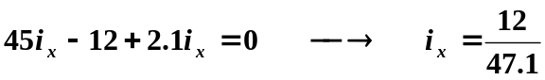 = 254.8 mA.

